Instructions for EXP 8
Implementation of BST & Binary tree traversal techniques. –insertion,traversal ,search
- Use Linked list Representation of Trees
- Define a structure for trees, as discussed in Lectures
struct node
{
int num;
struct node *left;
struct node *right;
};
struct node *tree=NULL;
- Write a menu driven program, wherein you can have-
  - 1 for Insertion in BST
  - 2 for Preorder Traversal
  - 3 for Inorder Traversal
  - 4 for Postorder Traversal
  - 5 for Searching
- Create separate functions for each of the operations listed above
- Put the switch case construct inside a loop
- Recursive Concepts for Insertion/Searching/Traversal can be used as discussed in Lectures
- Screenshots for Output of each and every Operation should be taken

Sample Working-
Insertion-
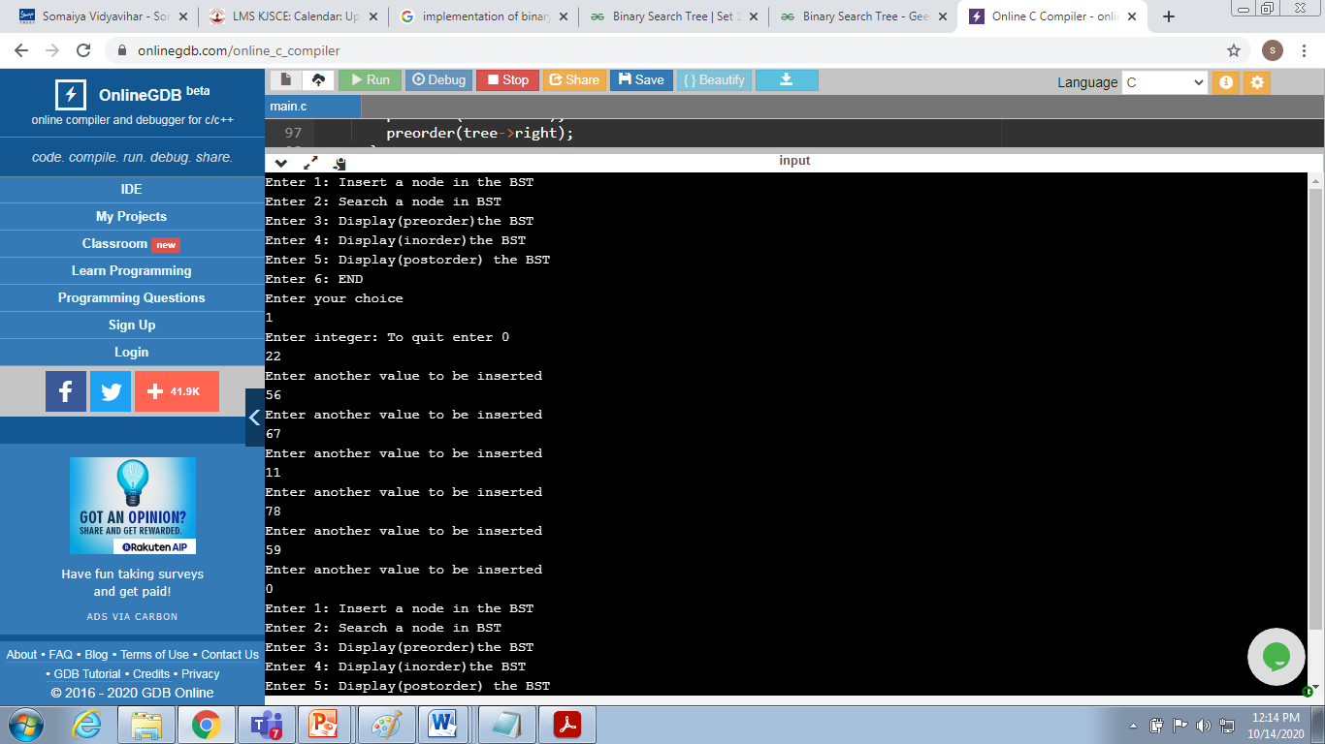

Display
Inorder Traversal
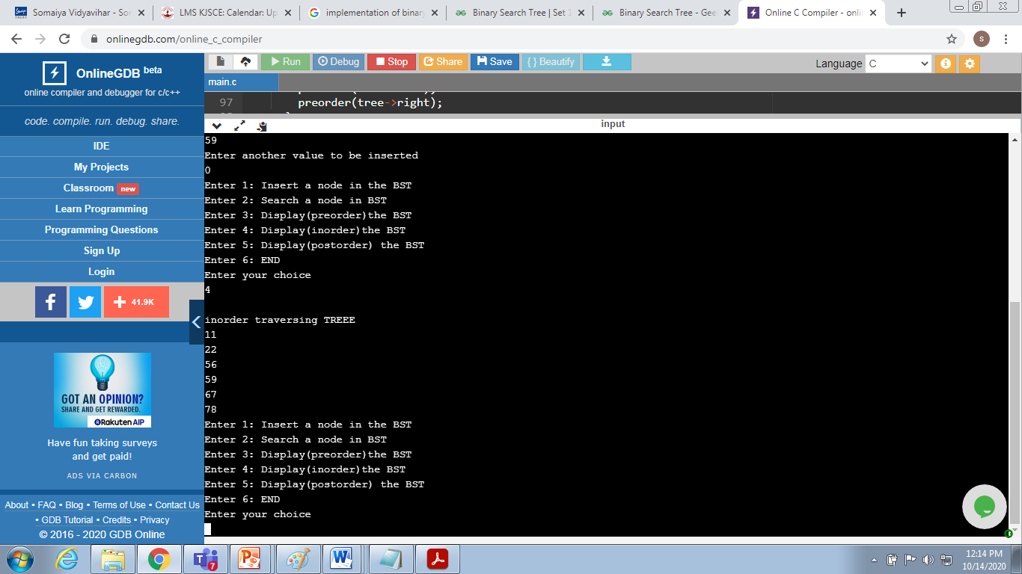

Preorder Traversal
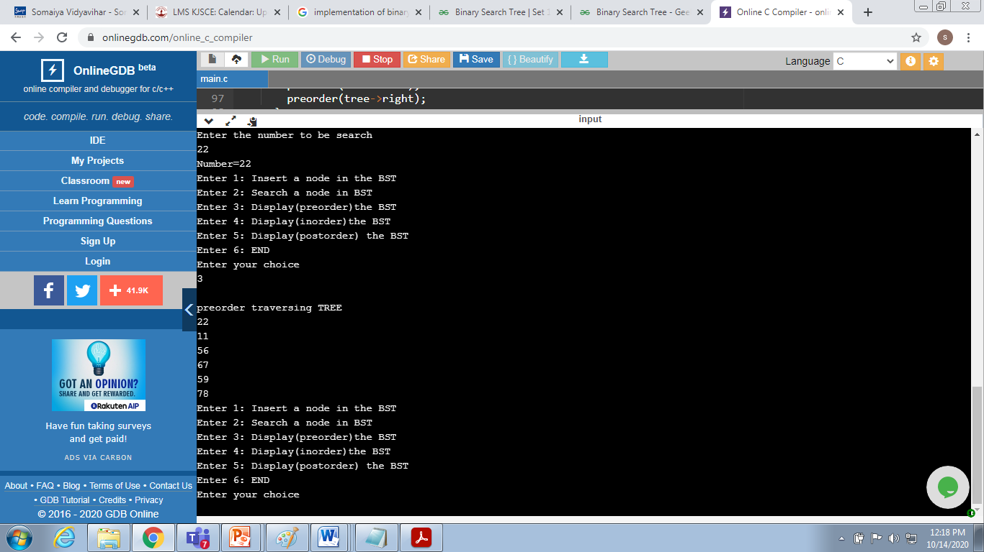
Search Operation
